**Experiment 15: AC Circuits - RLC Circuit**

# Introduction

An inductor (L) is an important component of circuits, on the same level as resistors (R) and capacitors (C). The inductor is based on the principle of inductance - that moving charges create a magnetic field (the reverse is also true - a moving magnetic field creates an electric field). Inductors can be used to produce a desired magnetic field and store energy in its magnetic field, similar to capacitors being used to produce electric fields and storing energy in their electric field. At its simplest level, an inductor consists of a coil of wire in a circuit. The circuit symbol for an inductor is shown in Figure 1a.

So far we observed that in an RC circuit the charge, current, and potential difference grew and decayed exponentially described by a time constant *τ*. If an inductor and a capacitor are connected in series in a circuit, the charge, current and potential difference do not grow/decay exponentially, but instead oscillate sinusoidally. In an ideal setting (no internal resistance) these oscillations will continue indefinitely with a period (T) and an angular frequency *ω* given by

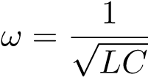 (1)

This is referred to as the circuit’s natural angular frequency.

A circuit containing a resistor, a capacitor, and an inductor is called an RLC circuit (or LCR), as shown in Figure 1b. With a resistor present, the total electromagnetic energy is no longer constant since energy is lost via Joule heating in the resistor. The oscillations of charge, current and potential are now continuously decreasing with amplitude. This is referred to as *damped* oscillations. The oscillations in the RLC circuit will not damp out if an external emf source supplies enough energy to account for the energy lost from the resistor. This energy is supplied from an oscillating emf source with an alternating current (AC).

If the applied voltage in an RLC is of the form

E = E0*sin*(*ωt* + *φ*) (2)

where E0 is the maximum amplitude of the emf, then the potential difference across each component can be written as

|  |  |
| --- | --- |
| *VR* = *V*0*R sin*(*ωt*) | (3) |

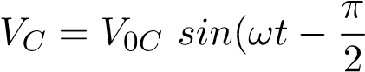) (4)

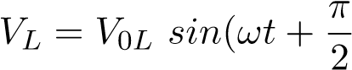) (5)

where *V*0*R*, *V*0*C*, and *V*0*L* are the maximum (amplitude) voltages across the resistor, capacitor, and inductor components respectively. The *ω* here is the *driving* angular frequency. Notice that the voltage across the capacitor *VC* lags *VR* by 90◦, and the voltage across the inductor *VL* leads *VR* by 90◦. All three voltages are plotted in Figure 2.

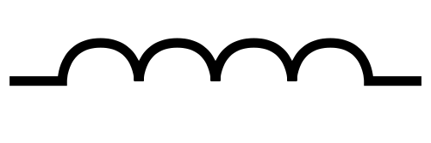

V

V

V

V

L

C

R

A

L

LRC

C

R

(a) (b)

Figure 1: (a) Inductor circuit symbol. (b) An RLC circuit.

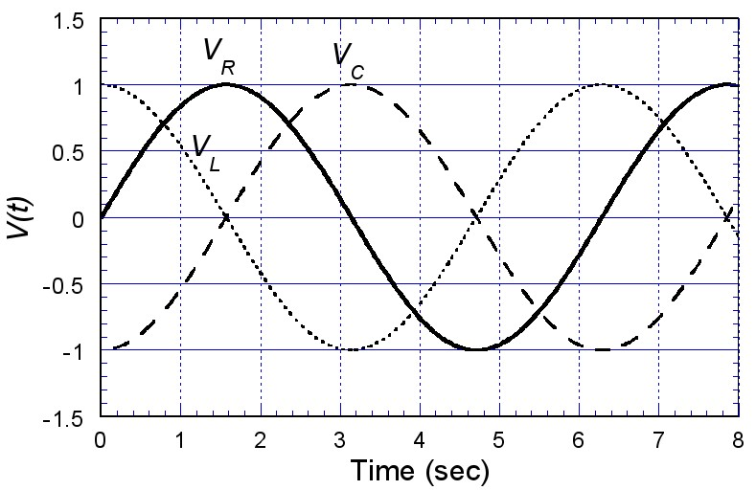

Figure 2: Phase relationships between voltages across the components of an RLC circuit. Using *VR* as a reference, *VL* leads by 90◦ while *VC* lags by 90◦. Note that the amplitude of the voltage for each component may not be equal as depicted but depend on the specific values of L, R and C.

In this lab we will only discuss *series* RLC circuits. Since the R, L, and C components are in series, the same current passes through them. The current in the circuit can be expressed in the form of Ohms Law as

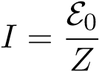 (6)

where Z is the *impedance* of the circuit defined as

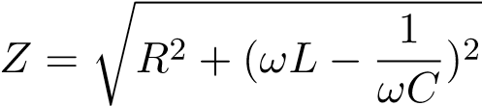 (7)

The impedance of a circuit is a generalized measurement of the resistance that includes the frequency dependent effects of the capacitor and the inductor. Notice from Equation 6 that the current I is at a maximum when Z is minimum. Thus, for a given resistor R, the amplitude of the current is a maximum when *ωL* −*ωC*1 = 0; that is, when

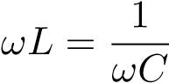 (8)

or written in terms of the angular frequency as

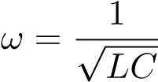 (9)

The maximum value of the current occurs when the *driving* angular frequency matches the *natural* angular frequency (Eq*.* 1) at *resonance*. In this lab we will study an RLC circuit with an AC source to create a resonant system.

**Procedure and Analysis:**

1. You are given a resistor, an inductor and a capacitor with nominal values of R = 12 kΩ, L = 0.1 H, and C = 10 nF, respectively. Using the inductance meter / multi meter measure the values of R, L and C and compare them with the given values.
2. Construct the circuit shown in Figure 1b using the breadboard with jumper-wires. Make sure that the resistor is the last component closest to the ground end of the circuit.
3. Turn on the signal generator and set the frequency of the oscillating signal to be approximately250 Hz (note: *ω* = 2*πf*). The time varying voltages will be studied using the oscilloscope. The oscilloscopes allow you to measure potential difference with respect to ground.
4. As a first exercise, we will observe the voltage on the oscilloscope when the” two” sources are in phase with each other. Connect the leads from CH1 and CH2 of the oscilloscope to the LRC circuit as shown in Figure 3. This means that both channels will measure the voltage across R.
5. Make sure both signals are visible on the display. Adjust the Horizontal and Vertical scale knobs to obtain a suitable display on the oscilloscope.
6. Are the signals from CH1 and CH2 in phase with each other? Why is this the case? Sketch the signals in your report.
7. Change the display selector from y-t to x-y (x vs*.* y). Use the display button and the “format” button found in the on-screen menu to toggle between the two settings. If both x and y are in phase with each other (they both reach their peaks and valleys at the same instant), the oscilloscope should display a straight line inclined at an angle (45 degrees if both inputs have the same magnitude and calibration scale). Verify this. Just as you directly observed the waveform in Procedure 6, this is another technique to check if the two signals are in phase with each other. This display is known as a Lissajous figure. Sketch this display in your report, remember to label the axis appropriately.



Ch 1

Ch 2

R

Oscilloscope

Figure 3: Oscilloscope connection for alternating current circuit. Note that only the resistor part of the RLC circuit is shown.

1. Change the settings to obtain the signal as in Procedure 5-6. Disconnect CH2 from the circuit and connect it to Point A as shown in Figure 1b. In this position, CH1 is still measuring the voltage across the resistor (*VR*), but CH2 is now measuring the voltage across all three components (*VRLC*). Adjust the vertical and horizontal scales to obtain the best display.
2. Are the two signals in phase with each other? Does *VRLC* lead or lag *VR*, and by how much? Sketch this in your report.
3. Observe the Lissajous figure for these two signals by repeating Procedure 7. Is this identical to the one you observed before? Sketch this in your report. You should now know what the Lissajous figure should look like when the signals are in phase and out of phase with each other.
4. Change the settings back to obtain the signal as in Procedure 8-9 (using the format button), but this time, set the display to show only the signal from CH1, which is *VR*. You should, however, leave CH2 connected as is.
5. Change the frequency of the signal generator (hint: you may want to increase the frequency) while continuously observing the amplitude of *VR*. Find the frequency where the amplitude of *VR* is a maximum. Change the vertical scale and the vertical positioning as you wish to help you accurately determine this frequency. Do not forget to read the frequency from the frequency counter. At this frequency, the current in the circuit is also a maximum, since *VR* = IR. Thus, from Equations 6 and 7, this is the resonant frequency of the RLC circuit.
6. Now change the display setting so that you again see both *VR* from CH1, and *VRLC* from CH2. From Equations 8 and 9, the *reactance* from the inductor (*XL* = *ωL*) and the reactance from the capacitor

(*XC* = 1*/ωC*) should cancel each other so that the impedance of the circuit just depends on the resistor. This means that *VRLC* should be in phase with *VR*. Is this what you observe?

1. Check this by observing the Lissajous figure at the resonant frequency. If the figure does not quite show the shape necessary for the two signals to be in phase, make the necessary adjustments to the frequency until you are satisfied that they are now in phase with each other. Record this frequency if it is different from the one you obtained before.
2. Using Equation 9, calculate the theoretical value of the resonance frequency and compare it with the value (or values if you have two different ones) you obtained experimentally. Take note that in Equation 9, you are calculating the resonance *angular* frequency *ω*.
3. Calculate the phase constant *φ* for procedure 9 - that is,

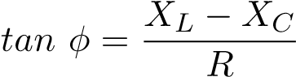 (10)

Is the circuit more inductive than capacitive or vice versa? How can you tell? What is the phase constant for the circuit in Procedure 13?

*A full lab report is not necessary for this lab. Answer the questions above and turn it in with your signed datasheet.*